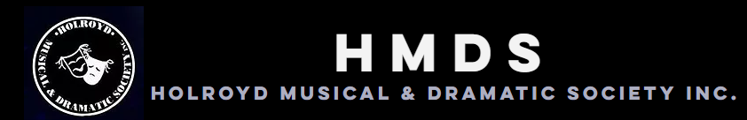

Presents

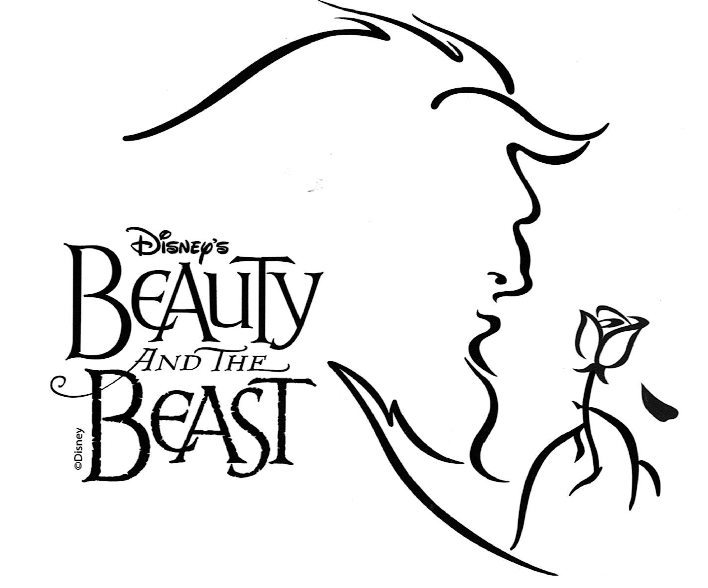
(June 2020)

Performances will be held at:

The Redgum Centre
(2 Lane Street, Wentworthville)

Performance dates are:

Friday, 12 June at 7.30pm
Saturday, 13 June at 1.30pm and 7.30pm
Sunday, 14 June at 1.30pm
Friday, 19 June at 7.30pm
Saturday 20 at 1.30pm and 7.30pm
Sunday, 21 June at 1.30pm

Producer: Holroyd Musical and Dramatic Society

Director & MD: Cathy Boyle - 0420 352 771
cathy.boyle1@gmail.com

Conductor: Kane Wheatley

Choreographer: Ste Casimiro

Production Manager: Helen Ruhle – 0412 968 750
vpahmds@gmail.com

AUDITIONS

PLEASE BRING A COMPLETED AUDITION FORM WITH YOU and ATTACH A RECENT HEADSHOT AND CV.

Where: Alan G Ezzy – Youth Centre – 1 Newport Street, Pemulwuy
When: Monday 2nd December, 2019
Start time: 7.30pm

Where: Linwood Hall – 25 Bryon Street, Guildford.
When: Wednesday 4th December, 2019
Start time: 7.30pm

Where: Linwood Hall – 25 Bryon Street, Guildford.
When: Sunday 8th December, 2019
Start time: 10am
(For children and absolutely desperate adults)

*** Please note: You must book your audition time. You may do this on Orientation Night or by contacting Cathy (Details on the first page).

Call-backs

Where: Linwood Hall – 25 Bryon Street, Guildford.
When: Sunday 8th December, 2019
Start time: 2pm

Rehearsals (starting Sunday 2 February, 2020 at 11am)

Monday and Wednesday evenings, 7.30pm – 10.30pm
Sunday (all day), 10.00am – 4.00pm. (Dates to be provided).
Rehearsal venues will be advised.

Audition FAQs

How are the auditions organized?

You will be required for no more than two hours. E.g. If your audition is between 7.30pm – 8.30pm, you will sing and then at 8.30pm you will do your dance audition.
If your audition is between 9.15pm and 10.00pm, the process will be reversed i.e. you will dance first at 8.30pm and sing second.

At our Sunday Dec 8 auditions, only children auditioning for the role of Chip (boys or girls will be considered) will need to sing alone. All other children will be allowed to sing in a group. A short song will be taught at the auditions. Children should be aged between 8 and 16 years at the time of auditions.

All children except Chip will primarily be dancers and will need to do a dance audition. This will be held in a group session after the singing on Sunday Dec 8.

What should I wear?

Wear comfortable clothes for the dance section of your audition. Jazz or chorus shoes are a good idea.

What should I sing?

If in doubt, sing a Disney song. It can be from the show if you like. The golden rule, though, is to sing something you know really shows off your voice.

A pianist will be available at auditions if you wish to use sheet music. You may also use a backing track for your audition but, especially if your track is on your phone, you will need to BYO speaker.

Adults who are auditioning only for the featured dance group may omit their singing audition or sing as part of a group.

Are there readings in the auditions?

Readings will only be required from those asked for callbacks. The required readings will be posted on the HMDS website (www.hmds.org.au) and HMDS Fb page.

What happens at callbacks?

You may be asked to sing a piece from the show. Callback songs will be available on the HMDS website and HMDS Fb page. Then you will be asked to read from one of the set readings.

Working with Children Checks
As children (persons under the age of 18 years) are being cast, the entire Adult cast (persons 18 years of age or older) will require a Working with Children Check (WWCC).
Apply at www.kidsguardian.nsw.gov.au

As you are in a voluntary capacity, there is no charge for your WWCC.

Please forward your WWCC clearance to Helen Ruhle (HMDS - V/President – Administration) at helenprops@optusnet.com.au (0412 968550)

SYNOPSIS

An arrogant young prince and his castle's servants fall under the spell of a wicked enchantress, who turns him into a hideous Beast until he learns to love and be loved in return. The spirited, headstrong, village girl Belle enters the Beast's castle after he imprisons her father Maurice. With the help of the Beast’s enchanted servants Belle begins to draw the cold-hearted Beast out of his isolation. Will they fall in love with each other before the last petal falls from the rose?

MALE CHARACTERS

Beast - A temperamental and domineering Prince who has been transformed into a terrifying beast for his lack of compassion. Although he can be hot tempered, he has a warm, loving heart buried under his gruff exterior. High bari. Sings to F.

Gaston – The tall, muscular hunter who is larger than life, rude, and self-centered. He will go to any length to get Belle to marry him. Actor should have great comic abilities without pushing for the laughs. 21-30. High bari. Sings to F.

Maurice – Belle's eccentric and lovable inventor father. Character actor 40-60. Baritone - Sings to D flat.

Lumiere - A suave, debonair, enchanted candelabra. He is the "Life of the Party" master of ceremonies of the castle. Strong comedic actor. 24-50 Outrageous French accent. Baritone - Tenor. Sings to F sharp.

Cogsworth – The tightly-wound, enchanted mantle clock and the head of the Beast's household; the height of propriety and order. A strong comedic, physical actor. English accent. Baritone. Sings to D.

Lefou - Gaston's bumbling sidekick. Physical comedian; acrobatics and/or clowning abilities a plus. High Baritone. Sings to F sharp.

Monsieur D’Arque - The sinister, devious owner of the local insane asylum, High Bari / Tenor. Sings to A.
Chip - An enchanted teacup, and Mrs. Potts’ darling little boy. Sings to C above Middle C (optional higher notes)

FEMALE CHARACTERS

Belle - A strong-willed, adventurous, vibrant, intelligent, young beauty. A classic beauty but unaware of her looks. Sings from F below middle C to F top line of stave.

Mrs Potts– A warm-hearted, very maternal enchanted teapot who tries to help Belle find comfort in the castle. She is the female head of the household. Cockney or Scottish accent. Sings F below Middle C - D

Babette – A saucy, enchanted feather-duster, and the object of Lumiere's affections. Actress should be able to be seductive with a comic flair; good dancer with a showgirl type figure. Outrageous French accent. Possible High C as top of range.

Madame De La Grande Bouche - A former opera diva turned enchanted wardrobe. She is the secret object of Cogsworth's affections. French accent. A comic actress with a possible High C

Silly Girls - Three young woman who compete obsessively for Gaston's affections.

ENSEMBLE CHARACTERS

Townspeople - The residents of Belle's town, they include a baker and a bookseller, and they perform the opening number "Belle”. They are also revellers in the tavern and they perform "Gaston" Some will also form the mob that goes to rescue Belle from the Beast's castle. Ages: 16 - 60. Voice: All types

Must dance and in a perfect world we will cast a group of approximately eight featured dancers. We can also consider some strong singers who move well.

Wolves - Non-singing and non-speaking, these roles are strictly movement and dance only. These wolves terrorize Maurice when he gets lost in the forest and Belle when she tries to leave the Beast's castle.

Enchanted Objects – These characters are the other animated objects in the Beast's castle. They could include a Cheese Grater, Salt and Pepper Shakers, Dishes, Silverware and Napkins for the "Be Our Guest" sequence, plus additional furniture for the "Human Again" sequence and the battle with the mob. All the enchanted objects are turned into humans at play's end.

Children’s Ensemble – A small group of 6-8 children could be cast in the production as enchanted objects, wolves and in the town scene. Dance ability and or acrobatic experience are highly desirable. Ages: 8-16 Must sing (as part of ensemble) & dance.

THE NARRATOR: We are looking for a voice to read the opening dialogue of the musical. It must be rich, beautiful and will set the mood for the whole show.

REHEARSALS:
Rehearsals will commence on Sunday 2 February, 2020 at 11am and take place thereafter every Monday and Wednesday nights from 7.30.pm to 10.30pm.
Rehearsals will be held in venues within the Cumberland Council LGA. Venues will be advised after Orientation.

Please come to rehearsals ready to work. Learn your lines as quickly as possible to allow more time to focus on scene work with your fellow actors. It is important to understand your scenes as well, so if you have any questions, please feel free to chat to the Director.
Please Note: If you miss more than 3 rehearsals during the rehearsal period without prior consent from Cathy, your position in the cast will be reconsidered. On your audition form you should list any dates you cannot commit to.
You will be provided with a script at your first rehearsal. You will be asked to sign for your script, which will be your responsibility until bump-out. A fee of $70 will be charged if not returned.
All cast are required to help at paint and set building days. You will also be asked to participate in any publicity days to be discussed at a later date.

HMDS and Committee
HMDS is a community theatre company, founded in 1951. The company is managed by an annually elected Committee of Volunteers.

President: David King
Vice President (Administration): Helen Ruhle (vpahmds@gmail.com)
Vice President (Production): Ivan Obreza
Treasurer: Martyn Carter (treasurer.hmds.@gmail.com)
Secretary: Susan Brown
Ticket Secretary: - Ashleigh King
Publicity Liaison: Alan Phillips
General Committee: Jill Foley, Wendy Hudson, Karen Breedon

Membership and Production Fees

Everyone in the cast needs to become a financial member of HMDS. Annual membership fees are:
• $15 Child / Student / Concession
- $20 Adults

Membership fees are due at rehearsal on Sunday 2nd February, 2020.

Production fees are payable for all cast.
A one-off production fee of $80 for each cast member is payable to cover costs.

Production fees are due within the first 4 weeks of rehearsal. The fees for this production are payable by cash or by direct debit to:
Commonwealth Bank
BSB: 062 202
Account: 1108 7403
Account Name: Holroyd Musical and Dramatic Society
Reference: Please include your surname as the reference
Receipts will be provided for cash payments or on request. Please contact the HMDS Treasurer, Martyn Carter at treasurer.hmds.@gmail.com if you require a receipt.
If you have any questions regarding fees please forward these to Martyn.

HMDS Beauty and the Beast Dates.

Orientation:
Wednesday 27th November, 2019 – 7.30pm
Wentworthville Community Centre – Grevillea Room – 2 Lane Street, Wentworthville.

Auditions:
Monday 2nd December, 2019 – Alan G Ezzy Youth Centre – 1 Newport Street, Greystanes

Wednesday 4th December, 2019 – Wentworthville Community Centre – Grevillea Room – 2 Lane Street, Wentworthville

Sunday 8 December, 2019 – Linwood Hall, 25 Bryon Street, Guildford.

Rehearsals:

Rehearsals will commence at 11am on Sunday 2 February, 2020.

A detailed schedule will be provided at our first few rehearsals.
If you have any questions, please contact:
Cathy Boyle (Director) – cathy.boyle1@gmail.com – 0420 352 771
Helen Ruhle (Production Manager) helenprops@optusnet.com.au – (0412 968 750)

